PHASE 5: Apex Programming
Debug Log Analysis and Bug Fixing in Salesforce Apex

1. Objective of Phase 5
The main focus of this project is writing Apex code that contains intentional bugs and debugging it using the Apex Replay Debugger.
This phase involves building the Apex classes and test classes that you will later deploy, test, and debug.
2. Creating Apex Classes
In this project, the primary Apex class created is:
AccountService.cls
This class is responsible for creating an Account record with the inputs:
- Name
- Account Number
- Ticker Symbol
The method:
public Account createAccount(String accountName, String accountNumber, String tickerSymbol)
Intentional Bug for Debugging
To support the debugging use case, the code includes a deliberate bug:
TickerSymbol = accountNumber;
This bug is later detected and fixed using the Apex Replay Debugger.
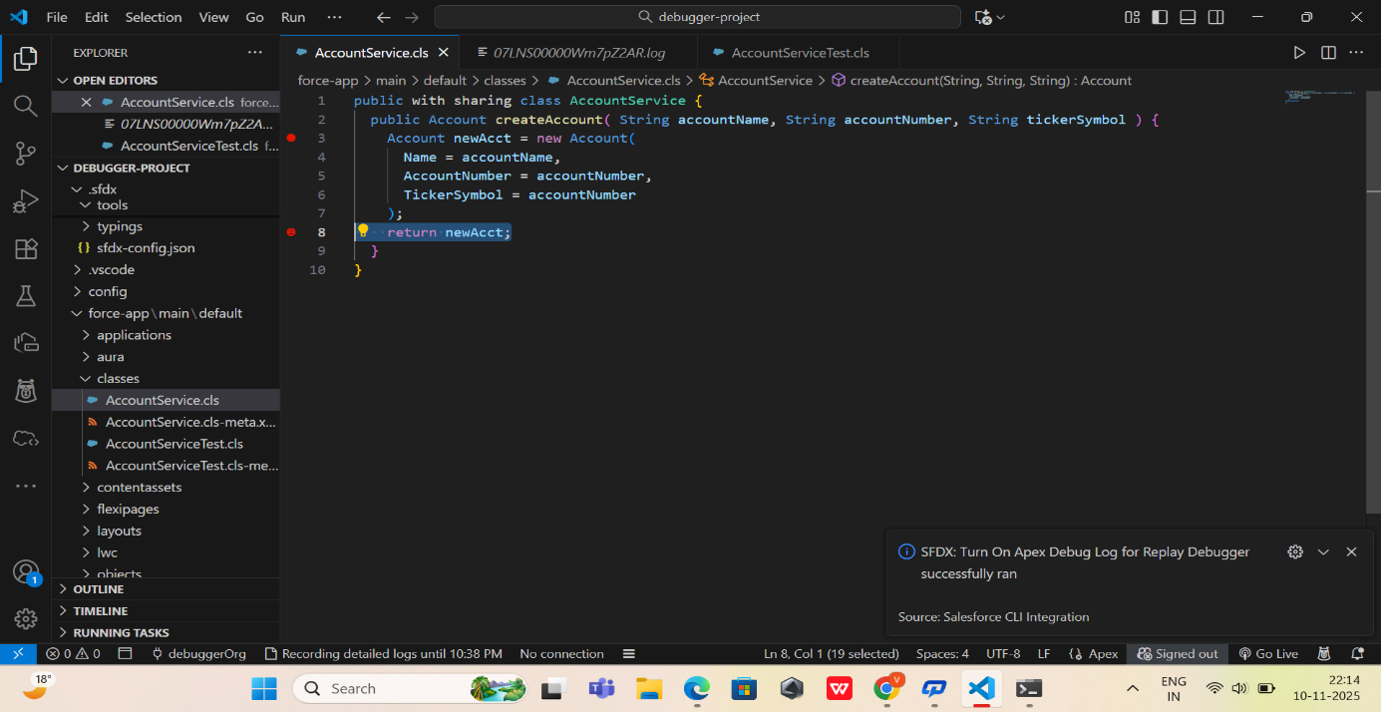

3. Creating Apex Test Classes
To verify and debug the Apex logic, you create the test class:
AccountServiceTest.cls
This class:
- Calls AccountService.createAccount()
- Inserts the Account
- Validates:
  - Name
  - Account Number
  - Ticker Symbol
Role of the Test Class
- Forces the Apex code to execute
- Generates debug logs
- Helps locate the bug during debugging
- Ensures your fix works after debugging
- 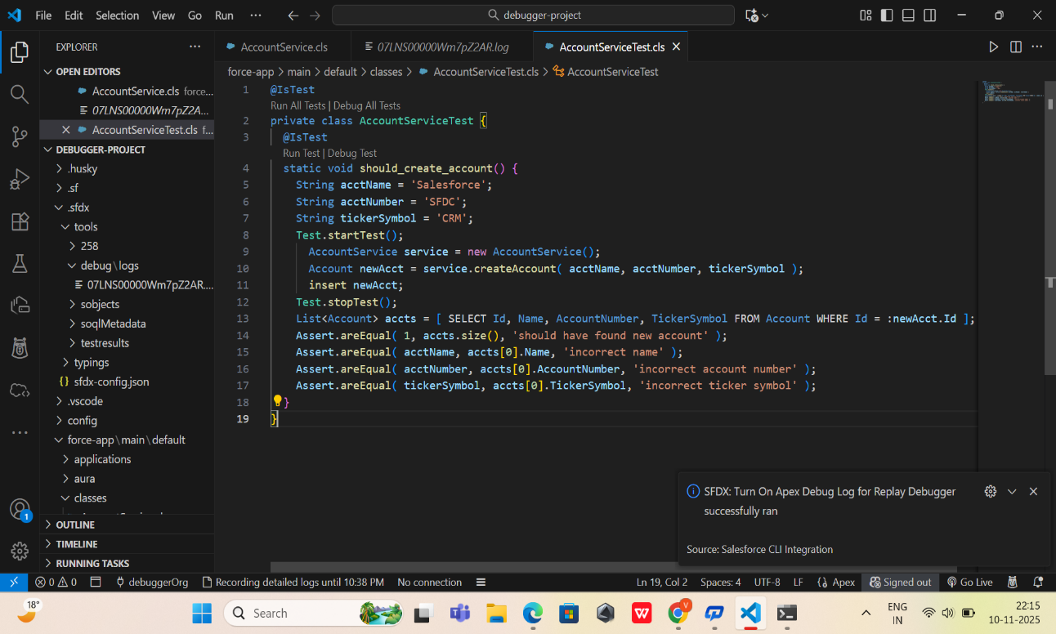

4. Writing Code for Debugger Compatibility
Code Requirements for Replay Debugger
To ensure the debugger works correctly:
- Apex Code should be deployed from the Salesforce DX project
- Code must match exactly what generated the debug log
- Test class must run with detailed log levels
- Logs must include FINER/FINEST granularity
These rules ensure breakpoints, checkpoints, and replay logs sync correctly.
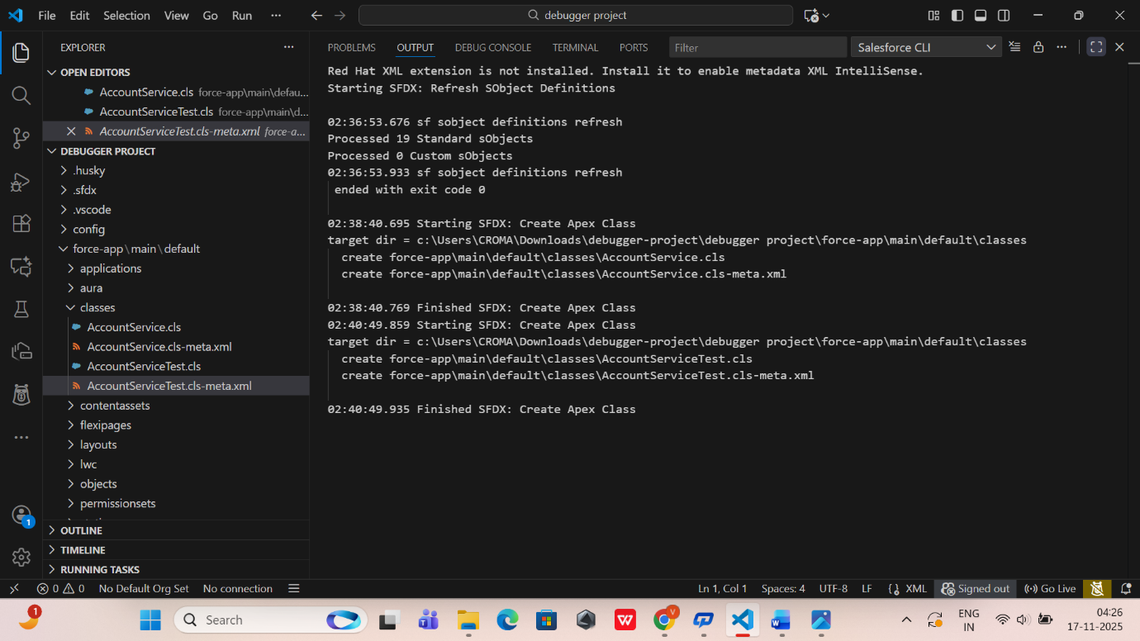

5. Deploying Apex Code to Org
Apex code is deployed using:
✔ SFDX: Deploy Source to Org
✔ Or right-click → Deploy this Source to Org
This makes the class available for execution and debugging in the connected Salesforce org.
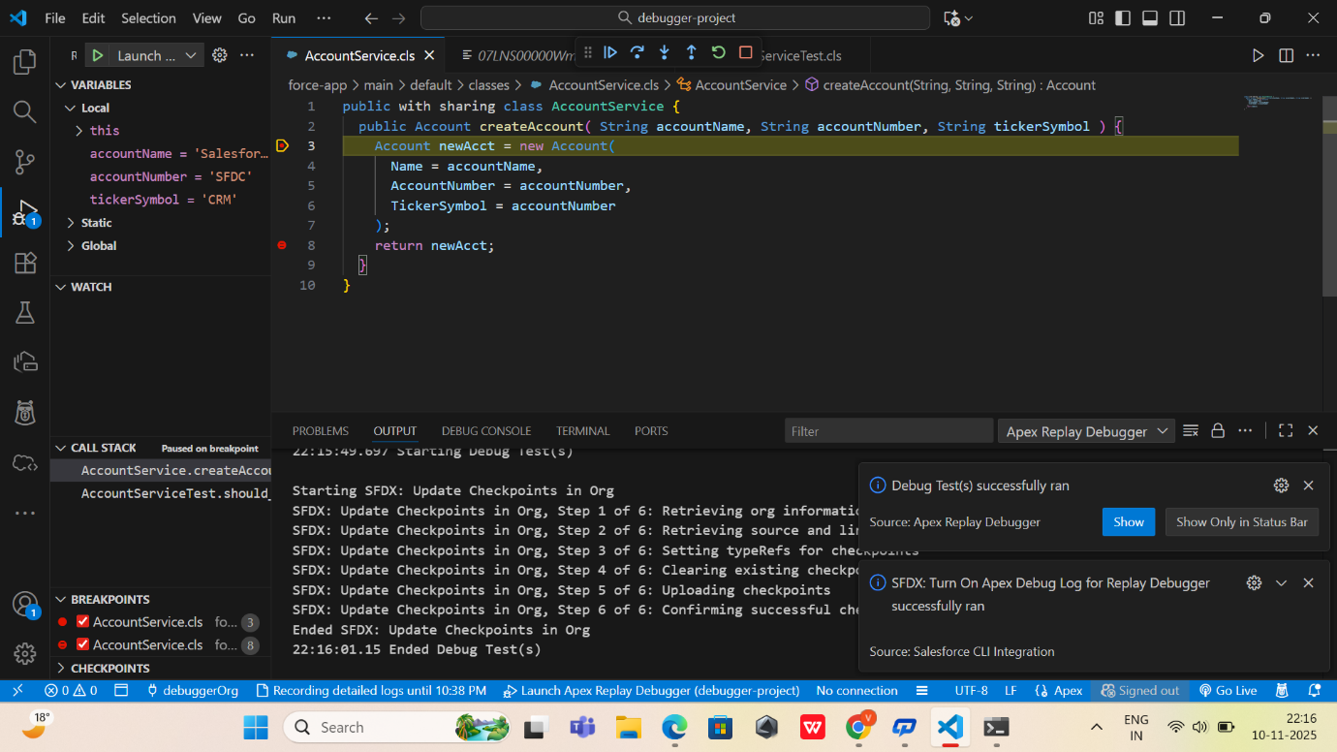
6. Purpose of Apex Programming in This Project
Although the project is debugging-focused, Apex programming is essential because:
✔ It provides real logic for testing
✔ It contains the bug that the Replay Debugger will detect
✔ It enables generation of heap dumps and breakpoints
✔ It demonstrates proper Apex development within Salesforce DX

7. Outcome of Phase 5
At the end of this phase, you will have:
✔ An Apex class (AccountService.cls) with intentional errors
✔ An Apex test class (AccountServiceTest.cls) to validate logic
✔ Successfully deployed Apex code in the org
✔ Setup ready for debugging, breakpoint setting, and log replay

